Behavior Analysis Monthly Report
Client Information
Client Name: | DOB:

Client/Caregiver Demographics
Name: | Phone:
Address:

Reporting Time Frame:

Plan Author and Credentials

Behavior Analysis Service Plan Objectives:

1. Overview: CLIENT NAME is a four-year-old who lives with her parents and sibling. CLIENT NAME grandparents are also very involved in her life as they help provide childcare for her brother in the home and client sees them all (maternal and paternal) on a weekly basis. Client currently also receives around the clock nursing care to support her current medical needs. Client was born via C-section at 40 weeks of gestational age, weighing 6lb 3oz. There were no complications throughout pregnancy, delivery or immediately following birth. Medical records show that after feeding problems and other complications, extensive medical testing lead to an Early Onset Myopathy, Areflexia, Respiratory Distress, and Dysphagia (EMARDD) diagnosis. Due to this client also currently has a tracheostomy and a G-tube.
Client has shown significant delays developmentally including, with language, motor movements and socialization. Client is currently unable to walk unassisted and therefore uses a wheelchair, which client can push unassisted for some time. Client is currently not potty trained and wears diapers. Client currently communicates using an augmentative communication device (ACD), sign language, by pointing and gesturing and answering “yes” or “no” questions. Per parent reports, the device can be used appropriately, but client often refuses to do so. It is also reported that client can follow most instructions given … “if client wants to”. Meaning that Client has the capability to understand and follow these instructions, as it has been observed in the past, but she refuses to do so. Clients parents report that she is able to identify, colors, letters, shapes and numbers and has started to show some reading skills. Client loves books and especially loves having them read aloud. Clients mother will ask to find the items in the pages which client enjoys, as well as pointing to items so they may be labeled. Client also loves playing educational games on her iPad, going for walks, going to the mall to “people watch”, throwing pennies in fountains and being out in the community. Clients mom reports that being out is her favorite things, so long as there are people to observe, though client rarely interacts with any of them. It has been reported by her caregivers that people who get in Client’s bubble, or near the face are often hit or aggressed towards, including

known family members, school peers and medical personnel. Client’s brother attempts to interact with client, as do her school peers, but they keep interactions brief due the history of aggression. This greatly limits Client’s interactions with adults and more importantly with peers. A token system was put in place towards the end of May with the intent of increasing appropriate behavior and decreasing inappropriate behavior. Family/staff across all settings have been trained to implement the procedure.

2. Targets and Observations:
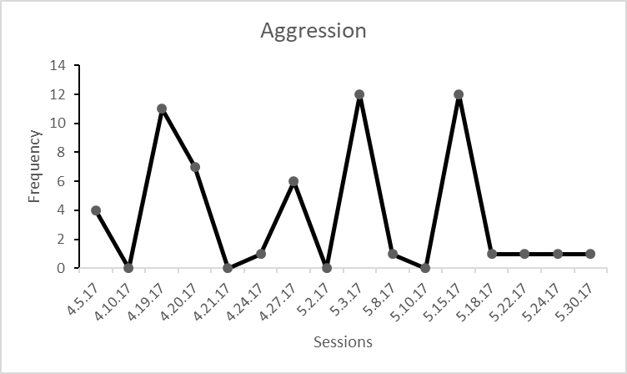
Aggression is more likely when demands are placed and when reinforcing activities are n
ot present.

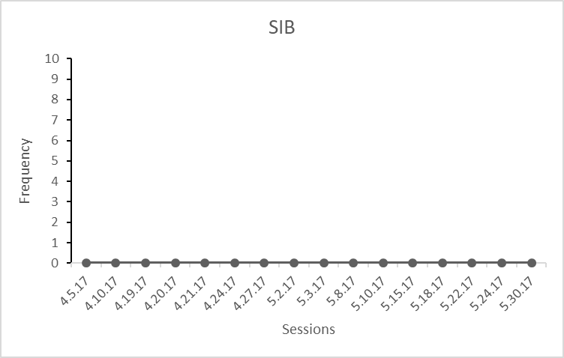
SIB has not been seen since treatment began.

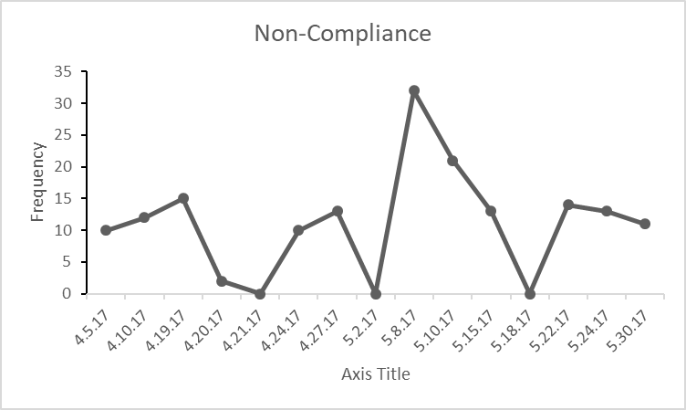
Non-compliance is more likely when a high rate of demands are placed and reinforcing items are not available or a more difficult task has been requested of her.

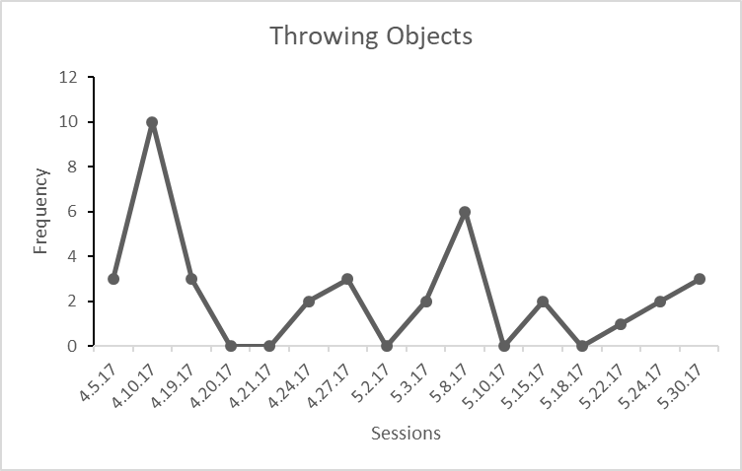
Throwing objects (e.g., academic materials) is more likely when demands are placed and reinforcing items are not available.

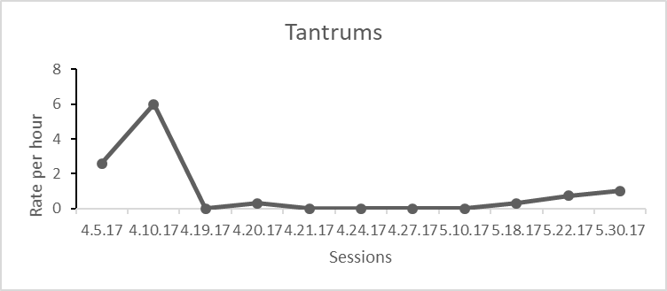
Tantrums occur at a low rate, overall. It should be noted that there was a slight increasing trend at the end of May. This will be addressed during the upcoming authorization period.

3. Recommendations and Efforts:

It is recommended that Client receives 30 hrs. of Behavior Analysis Service hours per week (14 direct/4 indirect for the BCBA’s, 2 hours of supervision per week for the BCBA-D, and 10hrs direct for BCaBA/RBT). The additional hours (BCaBA/RBT) are necessary to provide additional support for Client during sessions where client is being toilet trained. Intensive toilet training can be a very time-consuming intervention (8 hours/day). It is important to note that as Client gets older the behaviors may increase in intensity and/or frequency without proper intervention. Client’s aggression towards younger brother (2 years of age), food over-selectivity, difficulty potty training and non-compliance towards medically necessary treatments (e.g., Speech Therapy, Occupational Therapy) are especially concerning. An intensive potty training program will be added to her BASP. In addition, an additional emphasis will be placed on increasing her functional communication repertoire.

Check all that apply below:
Continue Program as is | Discontinue Program or Services | Retrain Caregivers
Revise Program | Medical or Other Consultation | Consider Transitioning or Fading

_________________________________________ ____________________________________
BCBA-D # Date:

