Domain | Objectives | Direct Behavior Rating | Proposed Action
Administration | - Submits BASP’s according to policy  - Follows timely discharge protocol  - Prevents lapse in authorizations  - Updates regional client ABA schedule  - Updates active client list | 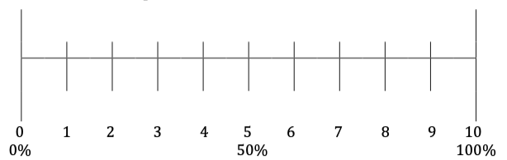  None Some All
Initiative | - Attends community events  - Attends/presents at research conferences under FSBA  - Markets FSBA at hiring events  - Makes connections with potential campuses  - Develops innovative strategies to increase client base/effective practice | None Some All
Communication | - Responds to communication within 24hrs  - Is the conduit for communication between providers and Leadership  - Provides routine updates on company policy  - Engages in routine conversation with caregivers/staff | None Some All
Professionalism | - Models a high standard of behavior when interacting with personnel  - Models a refined, context appropriate physical appearance  - Uses a behavioral approach to address concerns and provide feedback | None Some All
Leadership | - Monitors client utilization within the region  (4hr min/week)  - Monitors billing practices and balances caseloads of providers  - Organizes professional development events  - Monitors supervision standards according to BACB and company policy  - Develops training opportunities for third party members (e.g. schools) | None Some All
Direct Behavior Rating adapted from Chafouleas, Rilley-Tillman, Christ & Sugai (2009)

